25. In pl sql execute cursor in procedure.

Create table:

CREATE TABLE my_employees (

employee_id NUMBER(10) PRIMARY KEY,

first_name VARCHAR2(50),

last_name VARCHAR2(50),

email VARCHAR2(100),

phone_number VARCHAR2(20),

hire_date DATE,

job_id VARCHAR2(10),

salary NUMBER(10, 2),

department_id NUMBER(10)

);

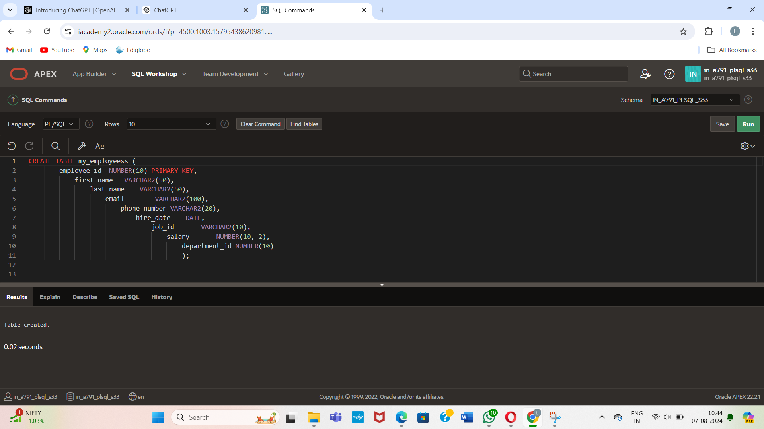

Insert values:

INSERT INTO my_employees (employee_id, first_name, last_name, email, phone_number, hire_date, job_id, salary, department_id)

VALUES (176, 'Alice', 'Williams', 'alice.williams@example.com', '555-1234', TO_DATE('2020-01-15', 'YYYY-MM-DD'), 'IT_PROG', 60000.00, 10);

INSERT INTO my_employees (employee_id, first_name, last_name, email, phone_number, hire_date, job_id, salary, department_id)

VALUES (1002, 'Jane', 'Smith', 'jane.smith@example.com', '555-5678', TO_DATE('2019-05-23', 'YYYY-MM-DD'), 'HR_REP', 55000.00, 20);

INSERT INTO my_employees (employee_id, first_name, last_name, email, phone_number, hire_date, job_id, salary, department_id)

VALUES (1003, 'Robert', 'Brown', 'robert.brown@example.com', '555-8765', TO_DATE('2018-11-30', 'YYYY-MM-DD'), 'SA_MAN', 70000.00, 30);

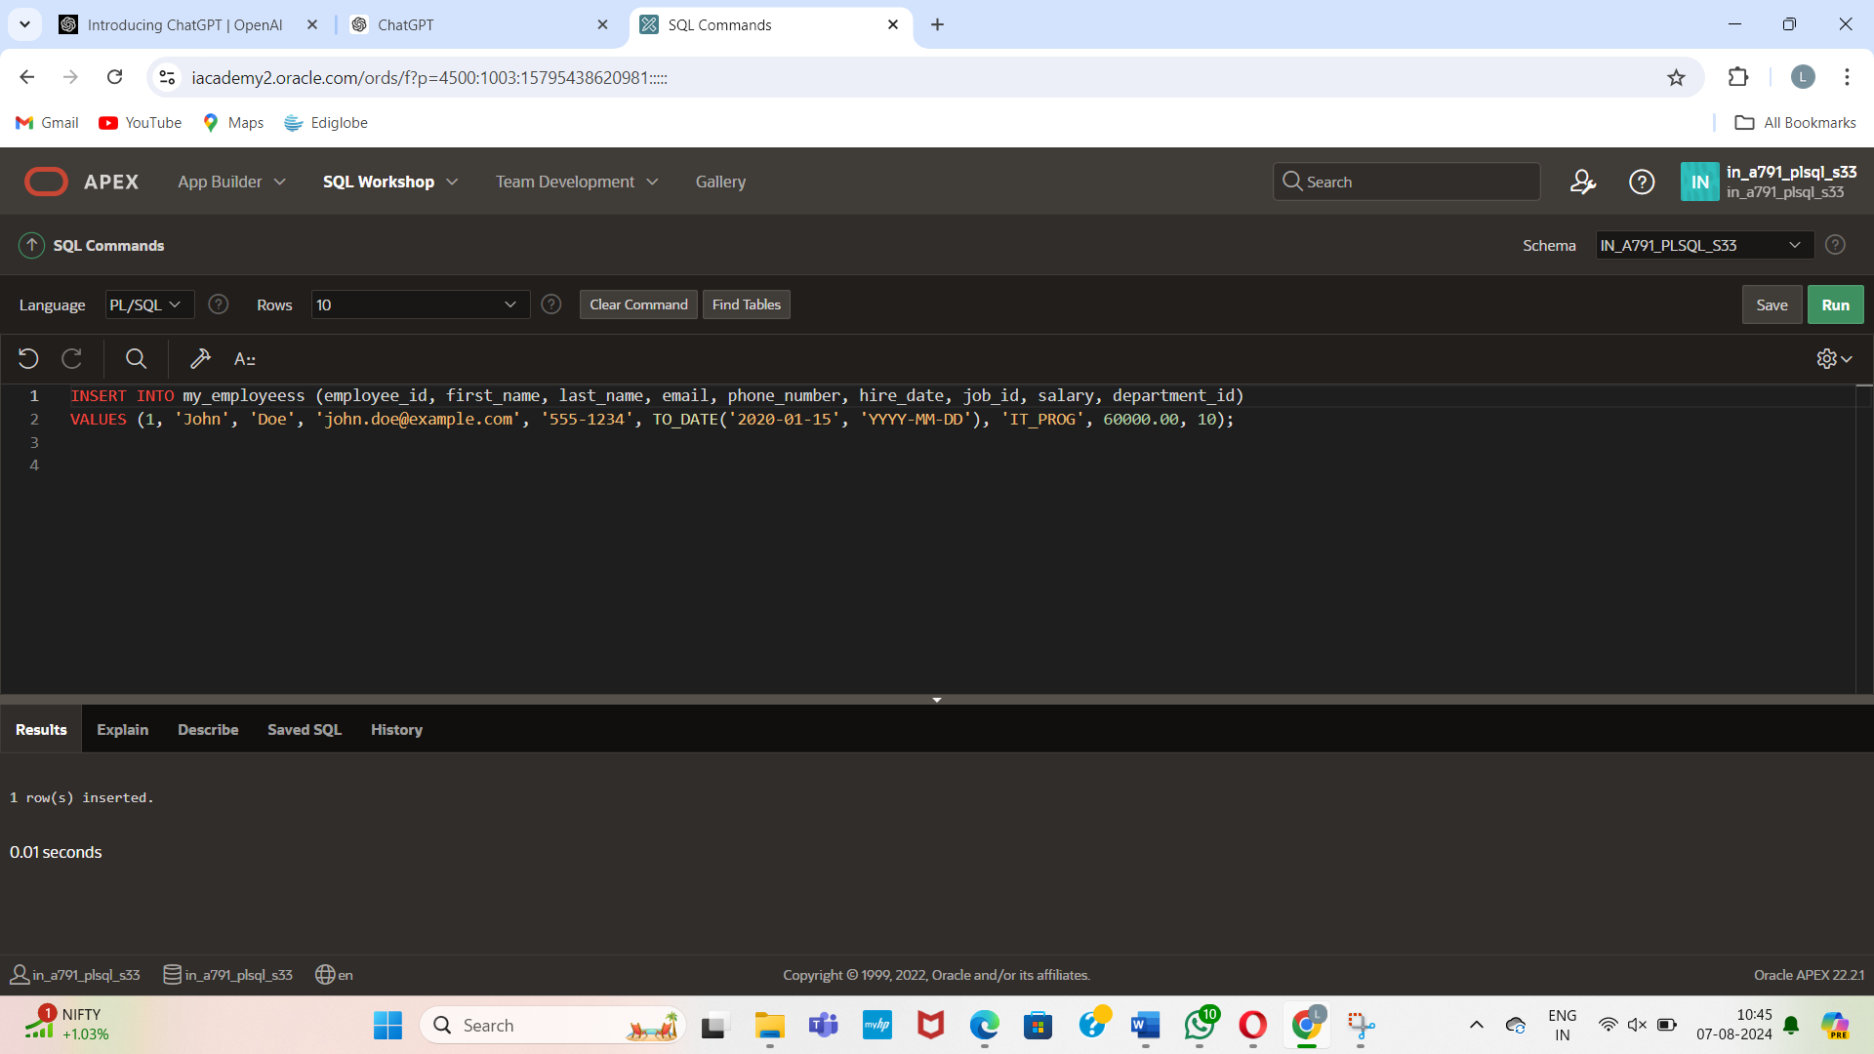

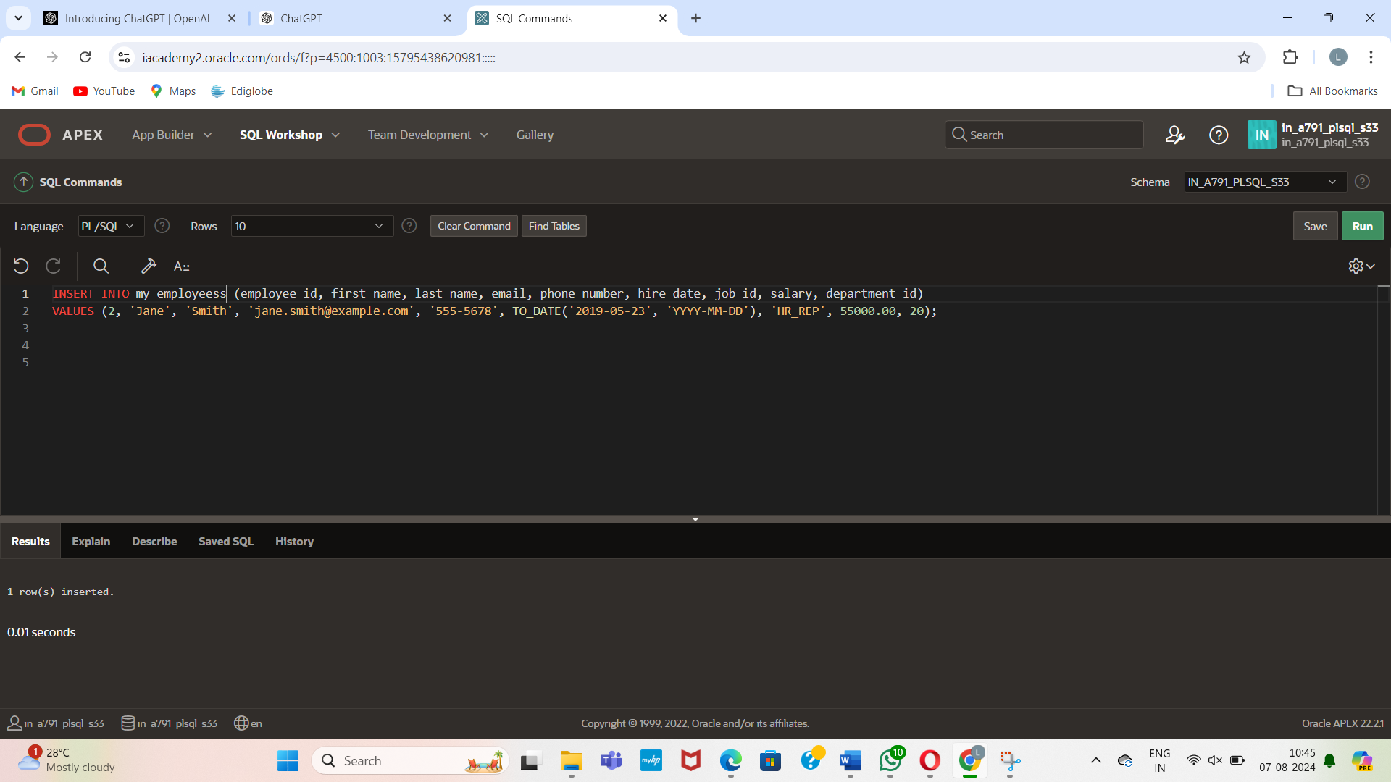

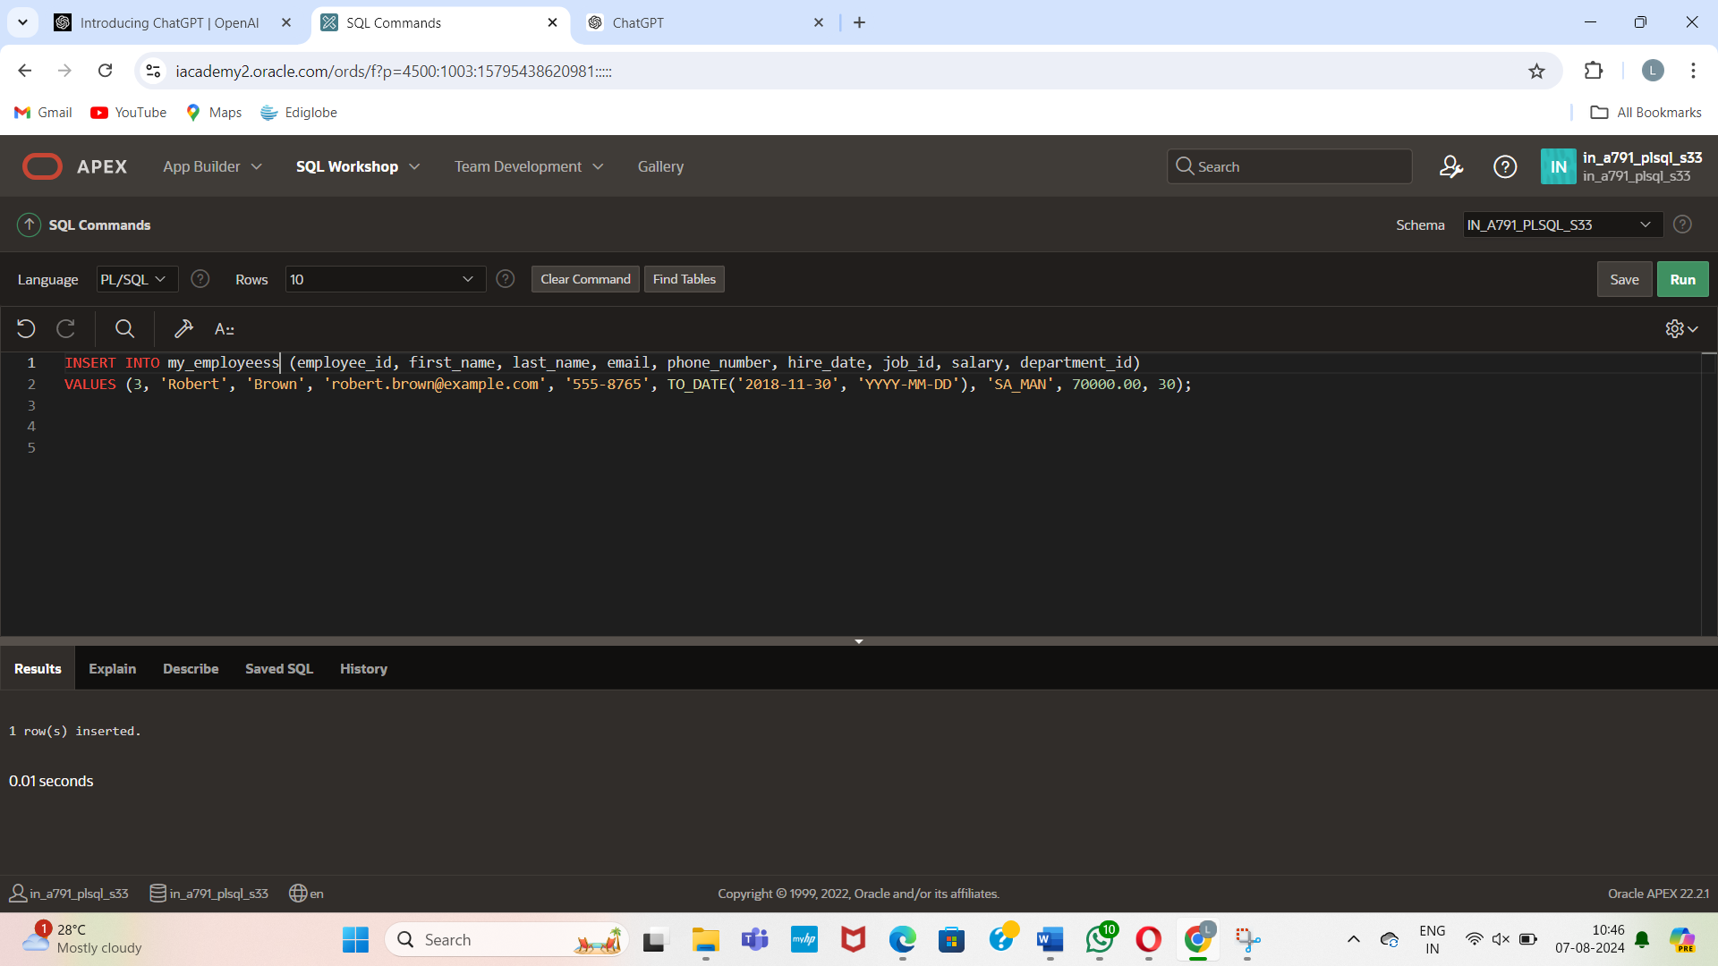

Create procedure:

**Create the raise_salary procedure**

CREATE OR REPLACE PROCEDURE raise_salary

(

p_id IN my_employees.employee_id%TYPE,

p_percent IN NUMBER

)

IS

BEGIN

UPDATE my_employees

SET salary = salary * (1 + p_percent / 100)

WHERE employee_id = p_id;

DBMS_OUTPUT.PUT_LINE('Updated ' || SQL%ROWCOUNT || ' row(s).');

END raise_salary;

/

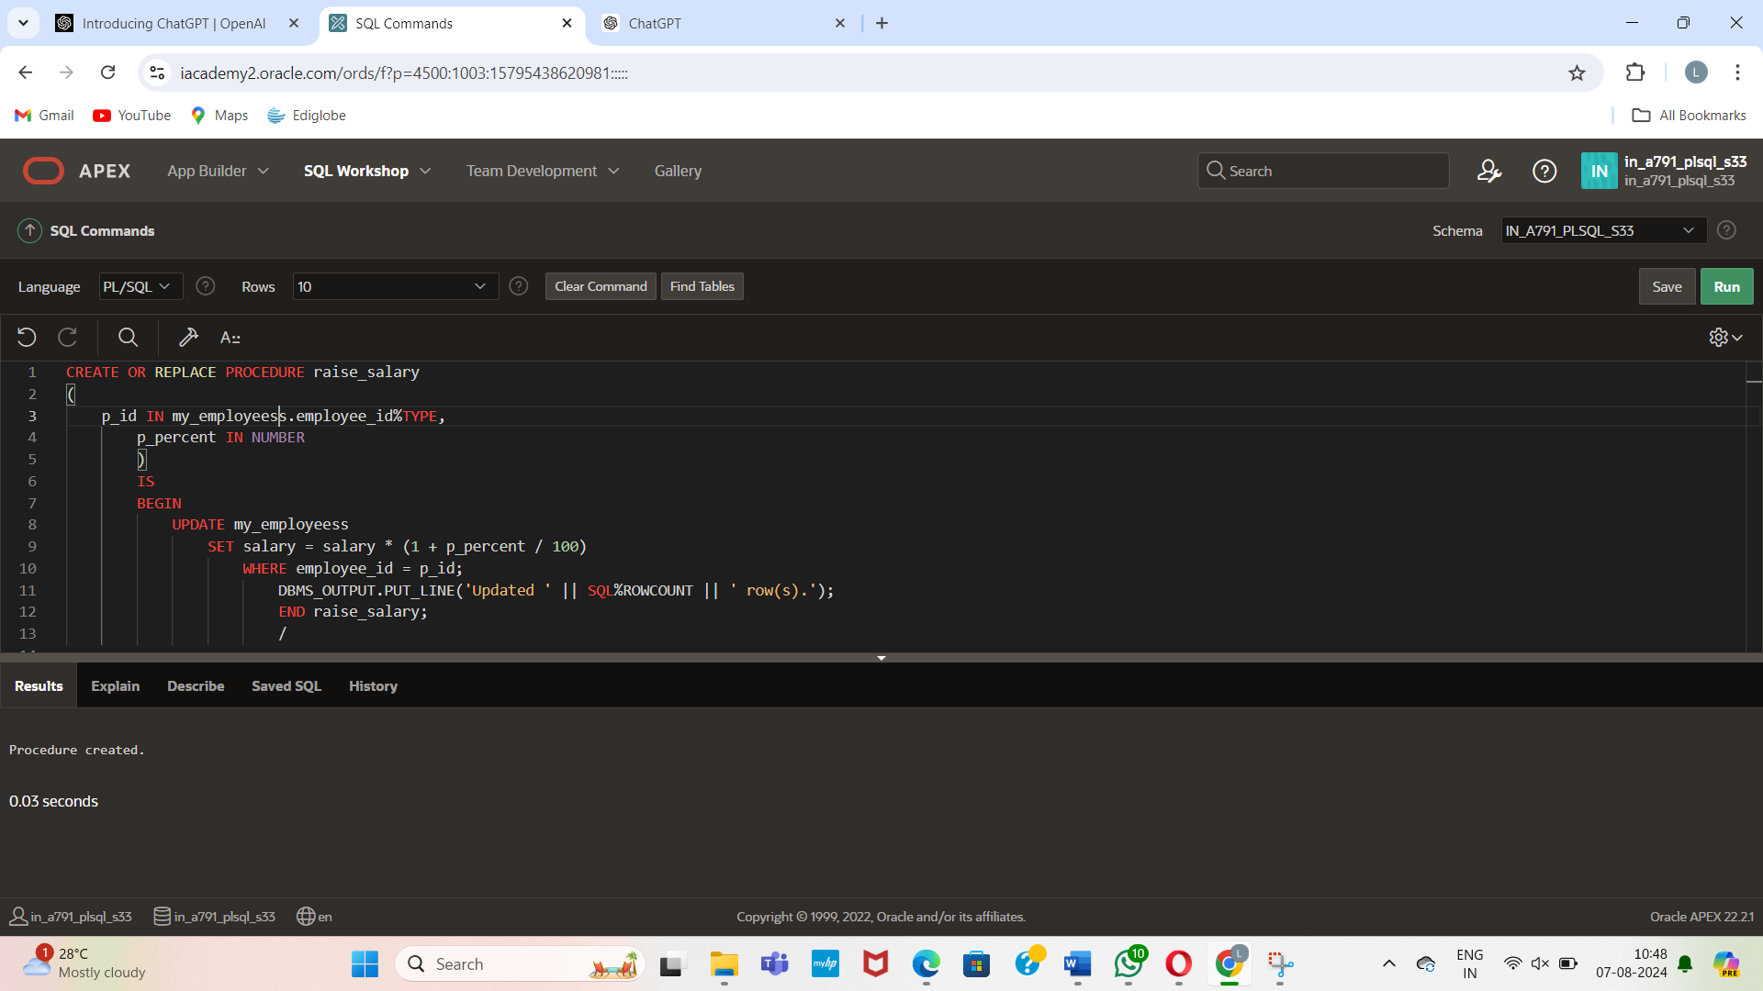

1. **Create the process_employees procedure:**

CREATE OR REPLACE PROCEDURE process_employees

IS

CURSOR emp_cursor IS

SELECT employee_id

FROM my_employees;

BEGIN

FOR v_emp_rec IN emp_cursor LOOP

raise_salary(v_emp_rec.employee_id, 10);

END LOOP;

END process_employees;

/

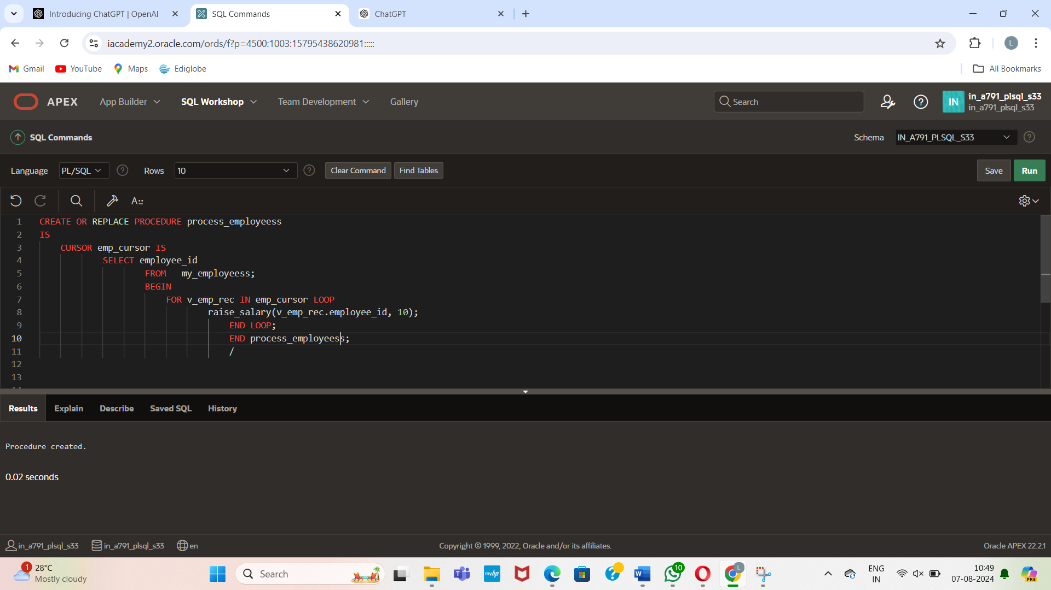

Output:

BEGIN

process_employees;

END;

/

